***Learning Styles***

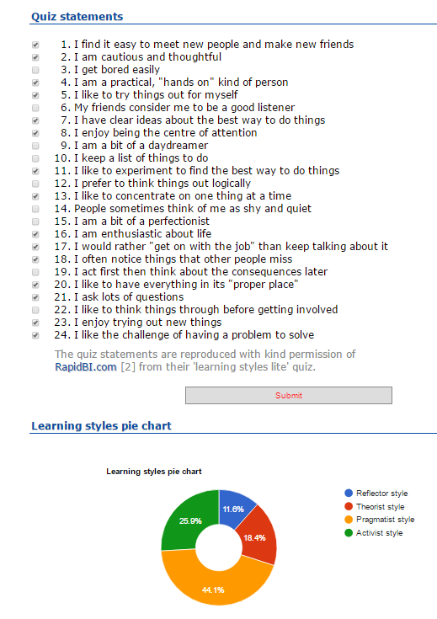

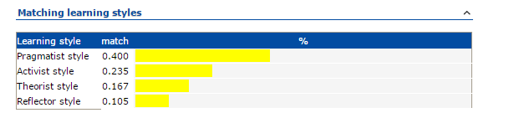

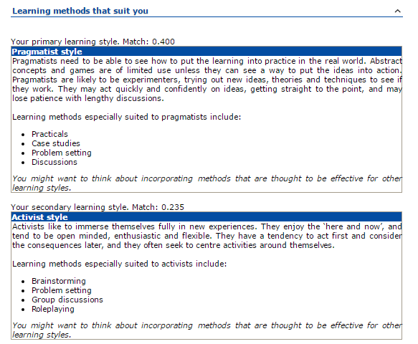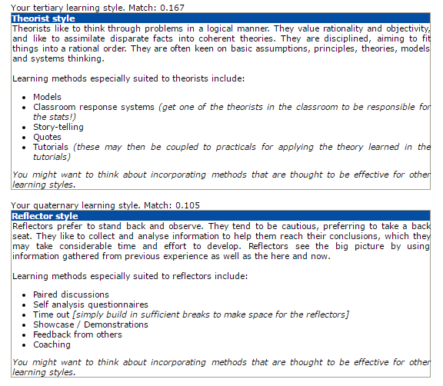



***Activist*: (Sourced from “The Manual of Learning Styles” by “Peter Honey” and “Alan Mumford”, First Published in 1982 By “Peter Honey”)**

These People usually involved themselves without bias in any new experiences. They do this in an open-minded fashion and involve themselves in the present moment. They are usually excited about new activities, especially ones that involve a new challenge. Usually actors over thinkers, they get bored with implementation of ideas very quickly and would rather get on with the work. They then get on with new ideas and demonstrate a gregarious personality (which means having an outgoing personality). One downside to their characteristic is they usually centre the activities around themselves.

**Activities best suited for Activists:**

Activist learn best from:

* There is a new challenge presented to them.
* It allows them to be fully engaged with the activity, such as competitions.
* There is a fluctuation which creates a number of challenges to be tackled.
* There is limelight around them. IE chair meetings, give presentations.
* Allow to generate ideas without constraints of policy
* Being thrown into a deep end with a task difficult
* Being involved in group work and being able to have a go.

Activist learn least from:

* Learning from a passive role
* Not being involved
* Required to analyse and interpret a lot of messy data
* Required to do solitary work
* Ask to assess work before and after assignment
* Given statements they see as theoretical and asked to repeat same activities over and over again
* Asked to do a thorough job- attend to detail

**Analysis of learning activities:**

**Management course:**

The amount of research, reading and the general environment instead of the plenty of “Present Mode” means this is not in interest.

**Marketing:**

Would not be interested due to the amount of solitary work involved and would “bump” off others for the information within the brochure given

**Action Learning Programmes:**

Would enjoy the practical work behind this type of work, and would be of more interest if it was related to a real world problem. However, the report afterwards and structure throughout the project work would be considered “boring” for the activists.

**Coaching:**

Being in the passive position where the coaching skill had to explained or demonstrated is unappealing to this category of learners. It would be more beneficial to them if they had a trial and error sessions with the expert(s).

**An experience of getting along with John (presentation or another activity from an more experienced person in same role):**

Would initially welcome the experiences regardless of whether it was made aware prior or it was on the spot. It would also be continued to be welcome if it was clearly related to the future role of the activist. However, if there was only slight relation, had already known the information already or do not understand the information being passed, then they would get bored and would not learn effectively.

**Outdoor Course:**

Enjoys the physical challenge of the outdoor. But the harder the outdoor activity, the more they will enjoy this activity but more dislike the reviewed process in the aftermath and results in more impatience with getting the review process done.

**A multi-discipline project team:**

Initially, the activists would take the challenge with full on enthusiasm. This will shortly fade into the project if there is specific objectives and semantics within the team. However, as long as their ideas are supported, their enthusiasm will continue.

**Summary of strengths and weakness:**

**Strengths:**

* Flexible and open-minded
* Happy to have a go
* Happy to be exposed to new situations
* Optimistic about the new and like change

**Weakness:**

* Do first thought actions without thinking through of what could be done
* Often take unnecessary risks
* Often do too much themselves and hog the limelight
* Rush into new activities without sufficient preparation
* Get bored with implementation

**An Activist Boss description:**

**Good at:**

* Generating opportunities for others to observe and reflect on their activities
* Take the positive review on a new topic
* Give an encouraging lead (at least for short term)
* Usually followed through with action to maximise learning experiences

**Bad at:**

* Providing planned learning experiences
* Giving support to learned as a planned, structured activity
* Assessing and using learning experiences which are different from those they already learned
* Discussing learning opportunities before and after activities
* Standing back and allow others to participate or take action
* Giving a good personal model of planned learner behaviour
* Giving different learning experiences to subordinates with learning styles

**An another Learning style associated with activist- Kinesthetic:**

This is learning by doing. For example, you learn how to program by consisting efforts at how to program itself or you get good at mathematics itself by practising the sums itself.

This learning style is similar to activist as both learn by doing some kind of activity to process the information. Both are also good at activities they keep doing, for example an athlete constantly trains at the beginning doing some different activity so they can learn what works for them.

Sum up what I said- both learn by doing an activity.

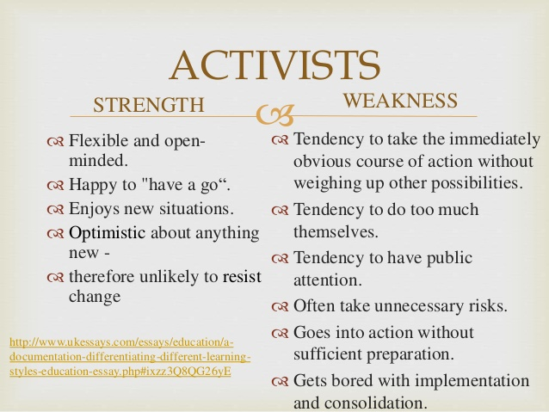

<http://www.slideshare.net/BijalShah15/different-learning-styles-1>



<https://i.ytimg.com/vi/UC0rvYekG9k/maxresdefault.jpg>



<http://www.lipscomb.edu/uploads/69733.jpg>



<http://inthesetimes.com/images/articles/trump_flicker_face_yess.jpg>



<https://media.licdn.com/mpr/mpr/p/7/005/0b7/3e9/1ed6dfe.jpg>



<http://www.alexanderking.co.uk/wp-content/uploads/2013/03/image_preview.png>



<https://thumb9.shutterstock.com/display_pic_with_logo/514156/125063342/stock-photo-bored-businesswoman-sleeping-in-a-meeting-as-her-colleague-who-is-giving-the-presentation-talks-in-125063342.jpg>



<http://the-isei.com/Libraries/Modern_Theme/leader_as_coach.sflb.ashx>



<https://media.mnn.com/assets/images/2015/08/ChildFrustratedByMathAtTheBlackboard.jpg.653x0_q80_crop-smart.jpg>

**Fun Fact- This learning had happened in your life before:**

Everyone remember their leaving cert?

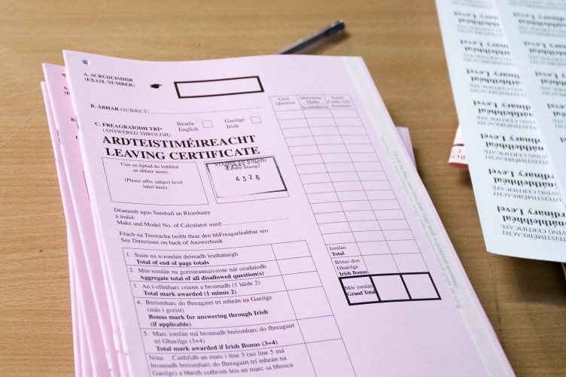

<http://c0.thejournal.ie/media/2013/08/leaving-certificate-paper-752x501.jpg>

This is the example where you had “to go through it”. The exam structure had put some under pressure, where others said “F*** It, it’s not worth it”.

The same effect will be in a few weeks, where the end of semester 1 leads to the exams in the aftermath.

Both for the majority of the human population, sex is the common activist activity where you “just go through it”. No one can teach you but you by doing it.



<http://www.thelanguageofsex.com/uploads/5/3/3/7/5337766/1323664.jpg?511>

**Peter Honey:**

Place of birth:  36 Holywell Sreet, Oxford

Degree:  BA (Hons) Psychology, Hull University, 1962

Started Peter Honey Publications: 1982

Met my wife to be: Singapore, June 1958

Children:  5

Grandchildren:  7 (6 boys, 1 girl)

**Alan Mumford:**